# Linear Algebra

Linear Algebra and its Applications by Gilbert Strang

Vectors: <https://www.youtube.com/watch?v=fNk_zzaMoSs>

<https://www.khanacademy.org/math/linear-algebra>

<https://machinelearningmastery.com/gentle-introduction-vectors-machine-learning/>

<https://www.youtube.com/playlist?list=PLZHQObOWTQDPD3MizzM2xVFitgF8hE_ab>

Why Learn?

Introduction to Vectors (2-D, 3-D, n-D), Row Vector, Column Vector?

* Point/Vector
* What is the distance of a point from origin?
* Distance between 2 points?
* Row Vector and Column Vector
* What does a dot b represent geomentrically?

Projection and Unit Vector

* Component Vise Addition
* Dot Product
* What sre a and b represnts geomentrically?

Projection and Unit Vector

* Unit Vector

Equation of a line(2-D), plan (3-D) and Hyperplane (n-D), Plan passig through origin, Normal to Plan

* Equation of Plan in a new Way

Distance of a point from a Plane/Hyperplane, Half-Spaces

Equation of a Circle (2-D), Sphere(3-D) and Hypersphere(n-D)

Equation of Ellipse (2-D), Ellipsoide(3-D) and HyperEllipsoide(n-D)

Square, Rectangle

Hyper Cube, HyperCuboid

# Content

### Why Learn?

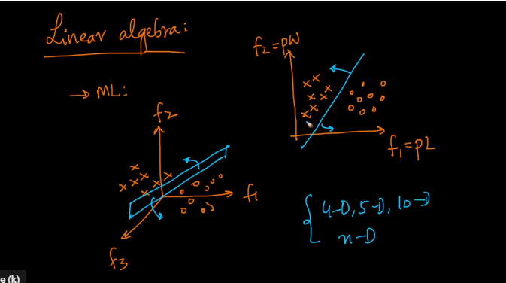

How do we generalize our learning or understanding from 2-D and 3-D to higher dimension space is where Linear Algebra helps us.

### Introduction to Vectors (2-D, 3-D, n-D), Row Vector, Column Vector

#### Point/Vector

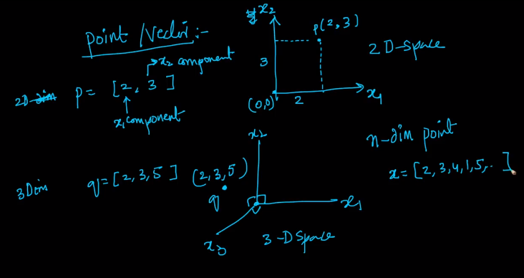

Lets assume 2-D cordinality system of x1, x2.

Lets assume a points which means it is 2 units away from my origin and 3 units away from origin.

So I can write P a 2-D vector with component 2 and 3.

Similary we can represent a 3-D space a Vector of size 3.

So for n-D point then

#### What is the distance of a point from Origin ?

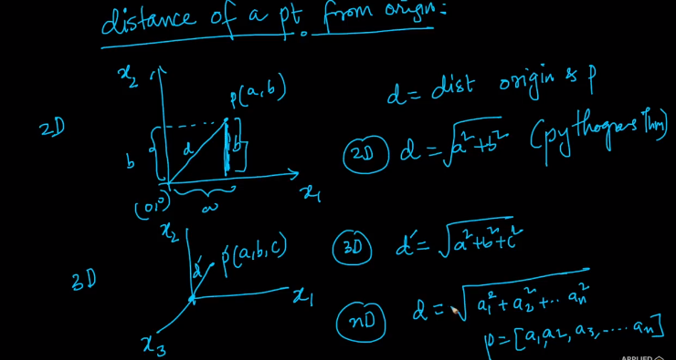

#### Distance Between 2 points ?

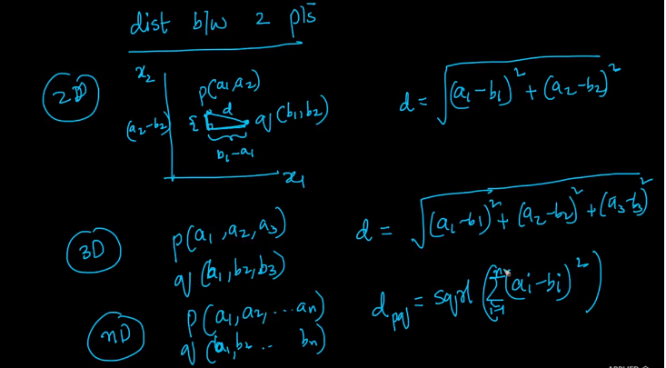

#### Row Vector & Column Vector

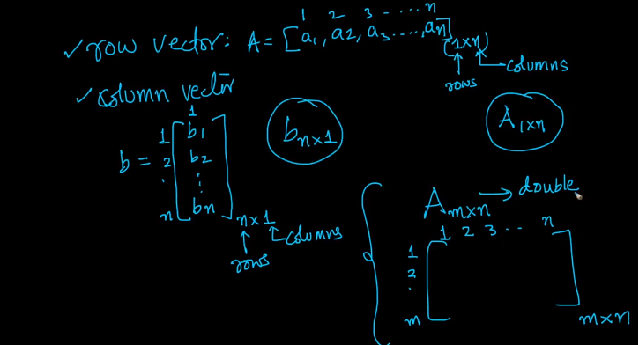

We Can think of matrix as a double array

### Dot Product and Angle between 2 Vector

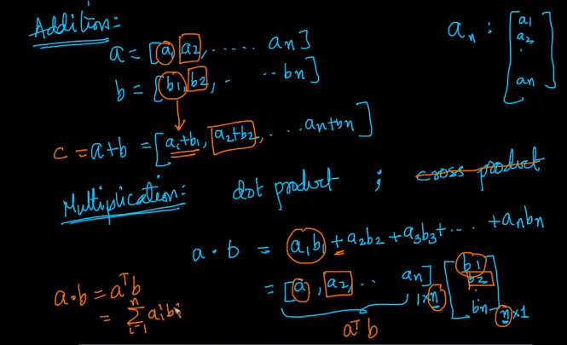

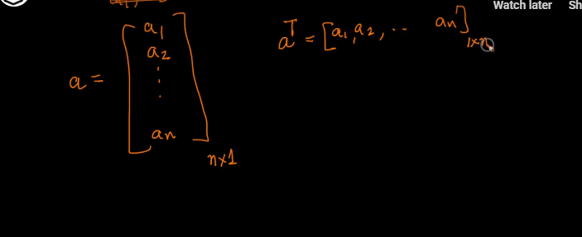

#### Componenet vise addition

#### Dot Product

Component vise multiplication

We can write a1b1+a2b2+..anbn in vector formate.If we have a row vector for a (i.e. 1xn) and column vector for b (i.e nx1).

Typically a vector by default a column vector

We can transpose a column vector to row vector as show above.

Finally a.b = aTb (This is a dot product from a pure algebraic prospective but let’s see gemoentrically)

#### What does a dot b represent Geomentrically?

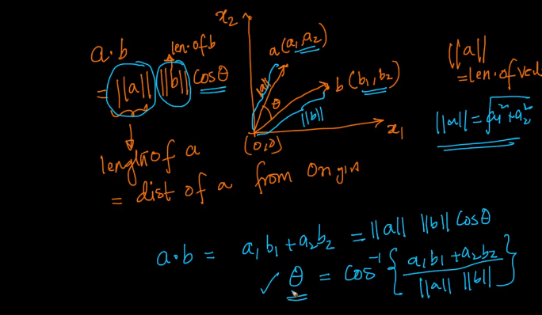

Teta is the angle

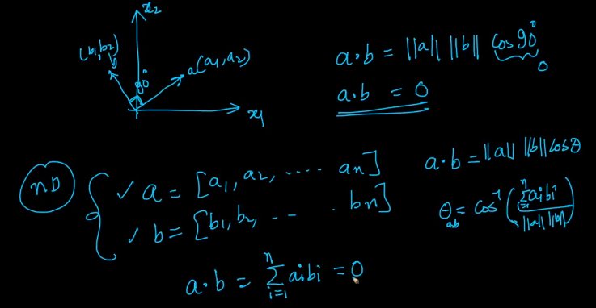

Lets Say I have 2 vectors and lets assume they are perpendicularto each other.

If dot product is zero that means they are perpenducular.

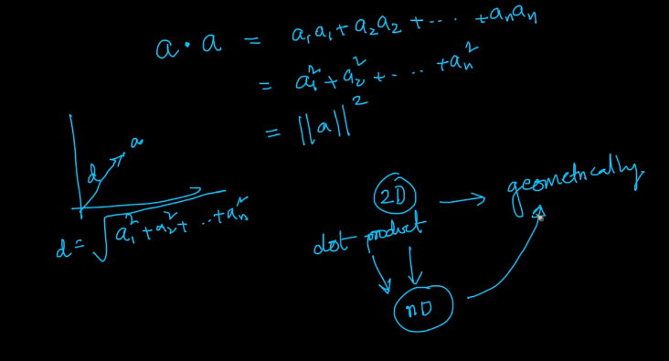

We wrote about dot product in 2D and we understood it geomentrically as angles between points and we are extending the same idea to n-dimensions with out visulization.

### Projection and Unit Vector

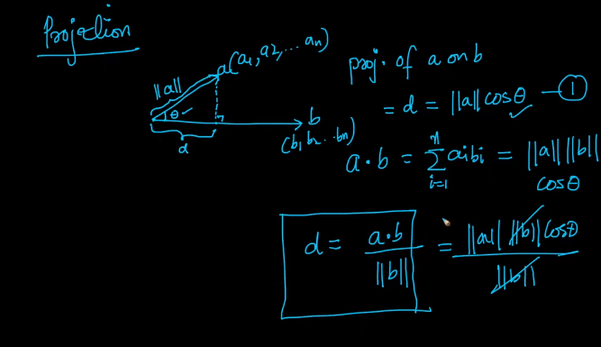

#### Unit vector

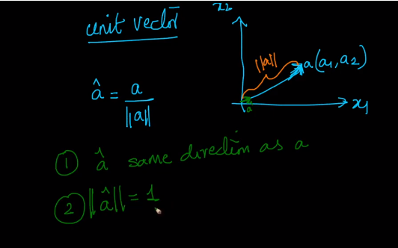

Unit vector is often represented by a cap

### Equation of a line (2-D), Plane(3-D) and Hyperplane (n-D), Plane Passing through origin, Normal to a Plane

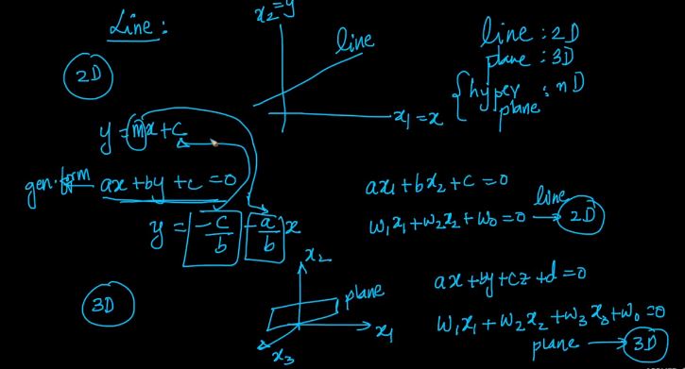

line , plan and n dimention Hyperdimension

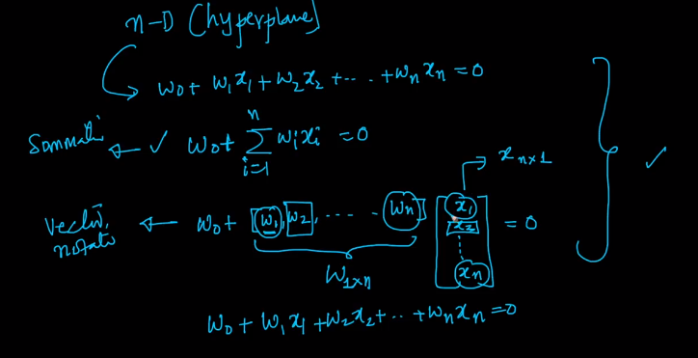

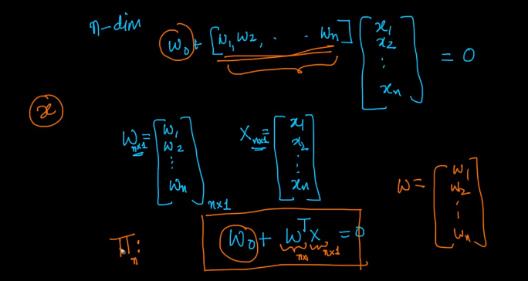

Pie represenst plan in hgher dimension space

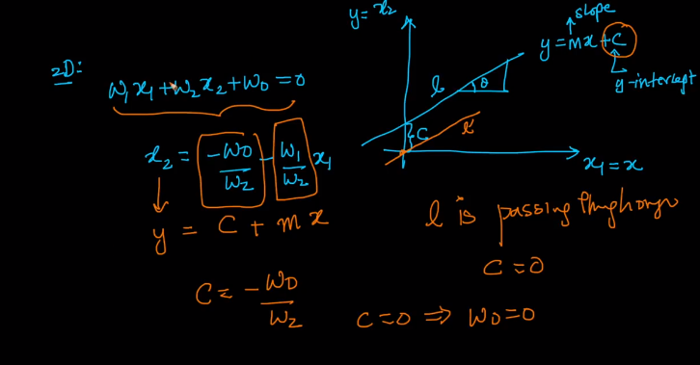

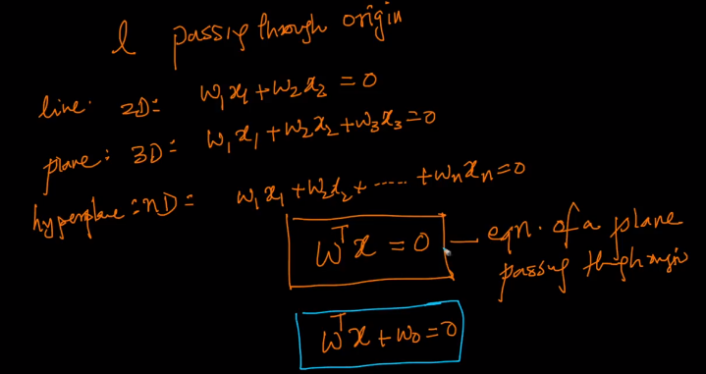

#### Equation of Plan in new Way

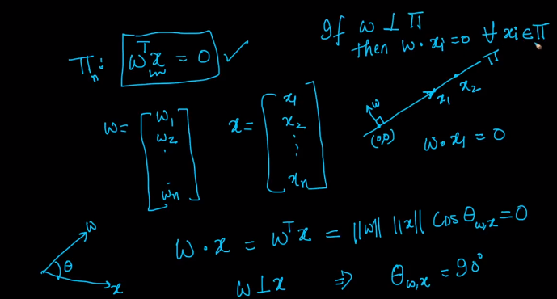

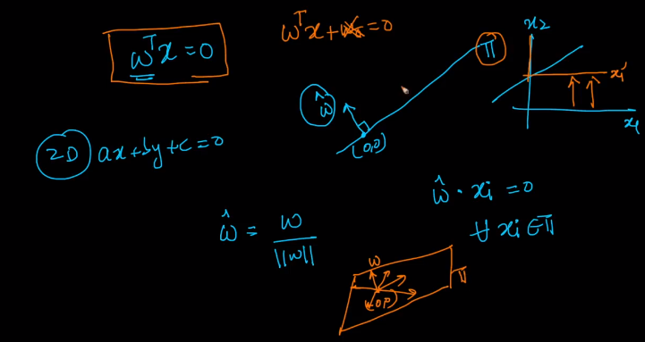

### Distance of a point from a Plane/Hyperplane, Half-Spaces

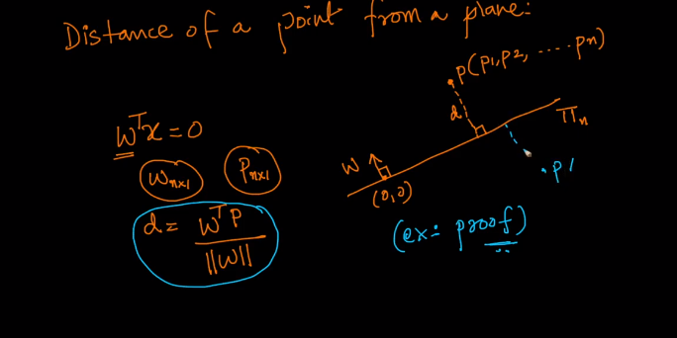

<https://imgur.com/a/0uQzVBV>

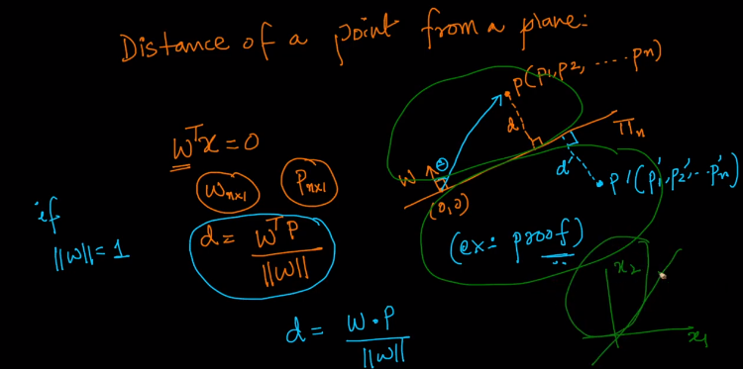

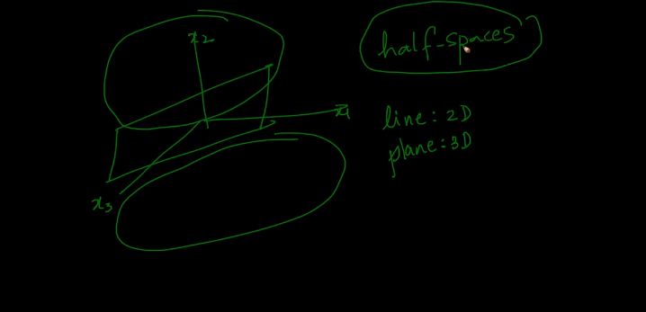

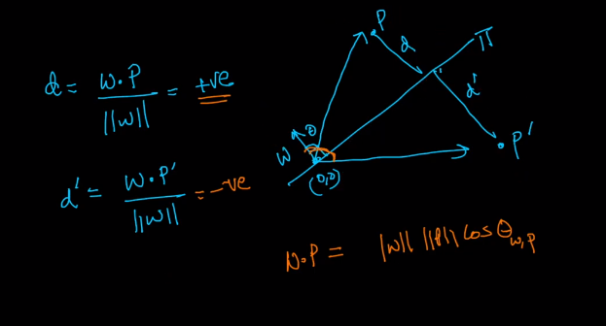

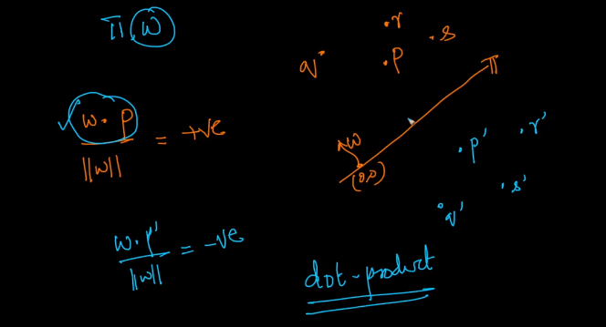

Given a plan pie which is defined by W , we can tell P line in one half spave if +ve and P|lies is other halp space when -Ve

### Equation of a Circle (2-D), Sphere (3-D) and Hypersphere (n-D)

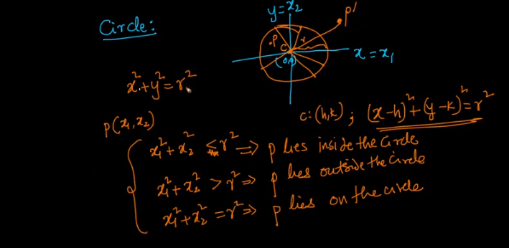

2-D c- center of circle if cenyter if origin x2+y2 =r2, if center is something else like c(h,k) then equation would be (x-h)2+(y-k)2=r2

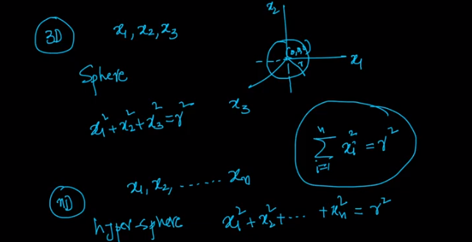

3-D



### Equation of an Ellipse (2-D), Ellipsoid (3-D) and Hyperellipsoid (n-D)

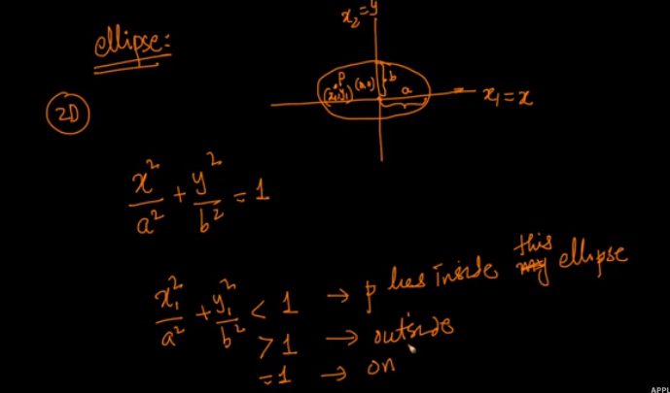

2-D

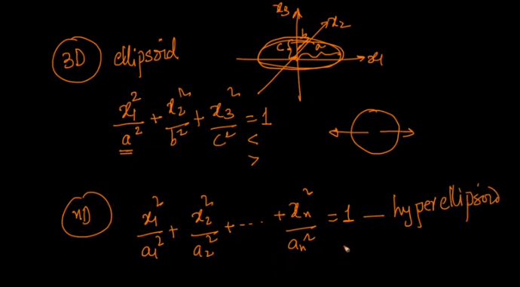

### Square, Rectangle

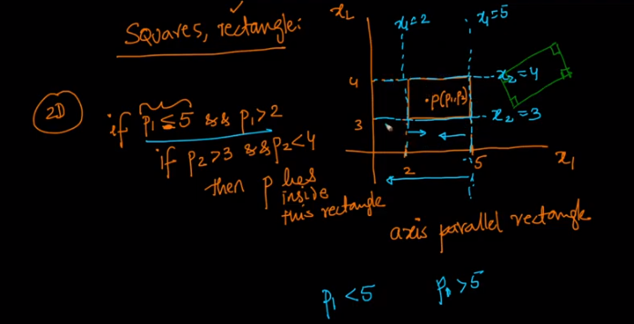

### Hyper Cube,Hyper Cuboid

